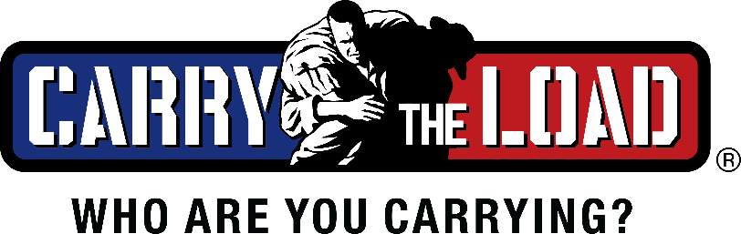

Carry The Load to Host the 11th Annual Dallas Memorial March
The Nation’s Flagship Event on Memorial Day Weekend

DALLAS (May 2, 2022) – Carry The Load, a non-profit that provides active ways to connect Americans to the sacrifices of our nation’s military, veterans, first responders and their families, will host its 11th Annual Dallas Memorial March on Memorial Day weekend at Reverchon Park in Dallas. The event starts on Sunday, May 29 at 12:00 PM and continues through the night until Monday, May 30 at 1:30 PM.

The Dallas Memorial March is a family-friendly event for people from all walks of life. Registration is complementary and encouraged at www.carrytheload.org/MemorialMay.

“If you and your family come and experience the Dallas Memorial March, it will change the way you do Memorial Day forever,” says Stephen Holley, co-founder, president and CEO of Carry The Load. “Being in that environment, walking side-by-side, sharing stories and teaching our youth about service and sacrifice demonstrates beyond words that people do care.”

The Dallas Memorial March is a two-day embodiment of the values Carry The Load hopes to further — a celebration of heroes, remembrance of the fallen, and education in respectful observance. It features inspirational speeches, stories of fallen heroes, flag ceremonies, walking route, storyboard procession, live music, KLTY Kids Zone, and more.

It is the culmination of the Carry The Load National Relay, which is a 32-day, 20,000-mile relay that includes five routes crossing 48 states and 100 rallies. Carry The Load has grown on a global scale to raise awareness for the true meaning of Memorial Day, and funds as a part of its Continuum of Care program.

Funds raised through Carry The Load assist with the many challenges facing our military, veterans, first responders and their families. Peer-to-peer fundraising goes toward recovery services, such as counseling, adaptive training, service dogs, suicide prevention, job placements, home improvements, scholarships for children of the fallen, and more. The 2022 goal is $2 million in peer-to-peer fundraising.

Sponsors of the 2022 Dallas Memorial March include Andrews Distributing, Bandera Ventures, Coors Light, Energy Transfer, Frito-Lay, Hillwood, Peinado Construction, Service King, Turner, USAA, WFAA and Wyndham Hotels & Resorts.

“It is ever so meaningful to see these sponsors, and countless other companies and organizations involved, come together for the true value of our freedom,” says Holley. “We exist to unite the country through one common purpose of honoring the lives of those who have gone before us.”

###

ABOUT CARRY THE LOAD
Carry The Load is a 501(c)3 nonprofit founded in 2011 by veteran U.S. Navy SEALs Clint Bruce and Stephen Holley. Carry The Load's mission is to provide active ways to honor and remember the sacrifices made by our military, veterans, first responders and their families. It focuses on three outreach programs: Awareness, Continuum of Care and Education. For more, visit www.carrytheload.org or news.carrytheload.org.

